
Key Instant Recall Facts
Year 6 - Summer 2
I know the first 5 cube numbers.
By the end of this half term, children should know the following facts. The aim is for them to recall these facts instantly.
A cube number is any number multiplied by itself three times e.g.
Key Vocabulary
Cube number
Cubed
1 x 1 x 1 = 1
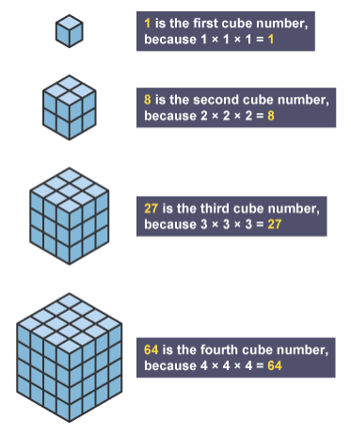
2 x 2 x 2 = 8
3 x 3 x 3 = 27
4 x 4 x 4 = 64
5 x 5 x 5 = 125
Children should be able to explain what a cube number is and recall the first five cube numbers quickly.
Use visual images to help children understand what a cube number is
Top Tips:
- Practise little and often
- Use your time wisely
- Practise KIRFs walking to school or on a car journey
- Perhaps have a ‘fact of the day’ to practise

