
Key Instant Recall Facts
Year 6 - Summer 1
I know the formulae for finding the area of different shapes.
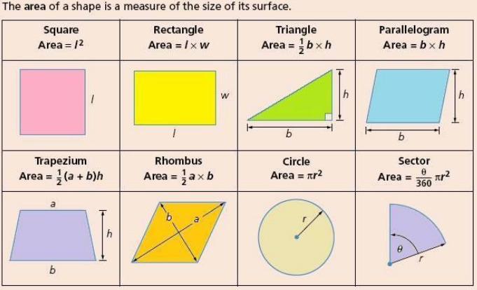
By the end of this half term, children should know the following facts. The aim is for them to recall these facts instantly.
Children should also be able to recall the formulae for finding the area of different shapes.
Top Tips:
Key Vocabulary
Area
Base
Height
Width
Pi
Radius
- Practise little and often
- Use your time wisely
- Practise KIRFs walking to school or on a car journey
- Perhaps have a ‘fact of the day’ to practise
- Use mathematical vocabulary accurately

