Cheapside C. of E. Primary School
Watersplash Lane • Cheapside • Ascot • Berkshire • SL5 7QJ
Telephone: (01344) 621112
Fax: (01344) 624035
Website: www:cheapsideschool.org.uk
E-mail: school.office@cheapsideschool.org.uk

Headteacher
Mrs Kate Searle
7th November 2022
Dear Parents

Racing To School Day - Ascot Racecourse
Owls class have been invited to Ascot Racecourse to take part in a ‘Racing to School Education Day’ on Friday 18th November. ‘Racing to School’ is an education charity that delivers outdoor learning activities at racecourses, studs and trainers’ yards across the Country. Please see the map below, which outlines to route that we will take to the racecourse.
Please make sure that your child arrives promptly to school at 8:40 am, wearing their school uniform and trainers with a coat, as they will be walking to and from the racecourse. Please provide your child with a packed lunch, water bottle and a snack for the day, as we will be eating on site. We will return for 3pm pick up.
The children will be taking part in several different maths and English based activities throughout the morning. They will enter the Weighing Room of the racecourse and learn about weights, measures, and their significance in racing. In addition, the pupils will also learn about the different jobs involved in the racing industry and may have the opportunity to visit the jockey’s changing area and handle the equipment. On the racecourse and parade ring, children will put their skills to the test measuring, constructing and estimating.
In the afternoon, the children will be taken to the Parade Ring and will explore the diet jockeys follow to be able to compete.
We are very fortunate to have been invited to participate in this fantastic programme. Whilst the charity does not charge for the day, running one of these events costs them approximately £1400. If you would like to make a voluntary donation that would go directly to ‘Racing to School,’ please pay via your scopay account.

This trip is covered under your child’s current OA4 for the year 2022/23, however, please could you also log on to your child’s scopay account to acknowledge receipt of this letter and give permission for your child to attend. If you have any queries, please do not hesitate to contact me via the school office.

Yours sincerely

Mrs M Rees
Class Teacher
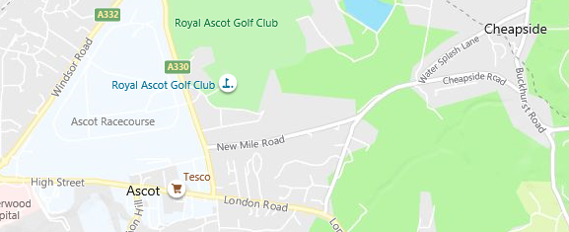

School

Racecourse entrance

