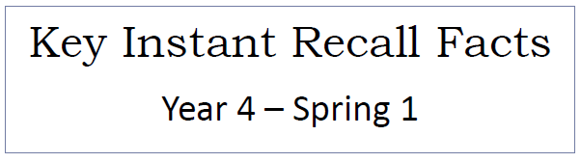


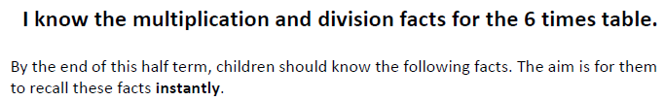

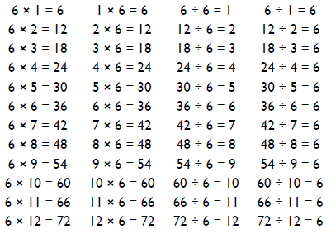
Key Vocabulary
What is 3 multiplied by 6?
What is 7 times 6?
What is the product of 6 and 2?
What is 24 divided by 6?
How many groups of 6 can you make out of 36?
What is the quotient of 42 and 6?
Divisor dividend divisible by multiple multiply

Top Tips
- The secret to success is practising little and often. Use time wisely. Can you practise these KIRFs while walking to school or during a car journey? You do not need to practise them all at once: perhaps you could have a fact family of the day. Double your threes – multiplying a number by 6 is the same as multiplying by 3 and then doubling the answer. 7 x 3 = 21 and double 21 is 42, so 7 x 6 = 42.
- Buy one get three free – If your child know one fact (e.g. 3 x 6 = 18) can they tell you the other three facts in the same fact family?
- Use Times Tables Rock Stars.
- Songs and Chants you can buy Times Tables CDs or find multiplication songs and chants online. If your child creates their own song, this can make the times tables even more memorable.
- Warning! When creating fact families, children sometimes get confused by the order of the numbers in the division number sentence. It is tempting to say that the biggest number goes first, but it is more helpful to say that the answer to the multiplication goes first, as this will help your child more in later years when they study fractions, decimals and algebra.
- E.g. 6 x 7 = 72 the answer to the multiplication is 72, so 72 ÷ 6 = 12 and 72 ÷ 12 = 6.

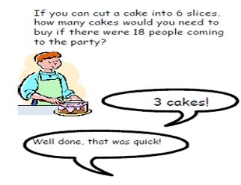
Make it Real!
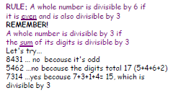

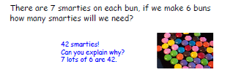

Make it fun!
Call out! Play ‘Beat the calculator’. One person works out the answer to a multiplication or division question with a calculator and the other person works it out in their head. Who is quicker?
Dice Roll a dice and generate a two-digit or three-digit number. Discuss whether the number is divisible by 6. How do you know?
Playing Cards Remove picture cards from the pack. Pick a card and state the multiplication and division fact for the three times table. E.g. pick the ‘9’ card so 9 x 6 = 54, 6 x 9 = 54, 54 ÷ 6 = 9, 54 ÷ 9 = 6
Dominoes To practise the 6 times table, pick a domino and add together the dots. The child multiplies the total by 6 and then give the associated division fact.
Songs and rhymes There are lots of CDs/ Apps available with musical tables. Great fun to sing along to on long car journeys!
Timed Games How well are you doing? How many questions can you answer in 2 minutes? Can you beat your own record?

