


I can count forwards and backwards in steps of 2, 5 and 10.
By the end of this half term, children should know the following facts. The aim is for them to recall these facts instantly.
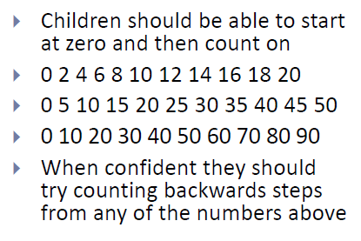
Key Vocabulary
How many tens can you count?
How many 2s do we count to make 10?

Top Tips
- The secret to success is practising little and often. Use time wisely. Can you practise these KIRFs whilst walking to school or during a car journey? You do not need to practise them all at once: perhaps you could have a fact of the day.
- Use objects to consider the bonds in a practical way. E.g. Your child has one potato on their plate and you give them three more. Can they say how many they will have?
- Look at the patterns with both objects and numbers. E.g. When counting in 5s, what do you notice about the end digit?
- Play games- your child can play online at www.conkermaths.com and then see how many questions they can answer in just one minute. Times Tables Rock Stars is also a great place for the children to practise their times tables.

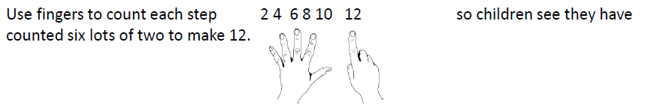

Make it real!
There are seven 5p coins in my purse. How much is there all together?

35p!
How do you know?
Because seven fives are 35.


I have 10 pence in my purse. How much more do I need to make 20p?
10p! Why? Because 2 groups of 10 are equal to 20.



Six teddies are sitting on a shelf, 2 are added to the teddies. How many are there altogether? Eight! Why? Because 6 plus 2 is 8.

Make it fun!
Call out!
- Play number ping-pong. Start by saying ‘ping’ and the child replies with ‘pong’.
Repeat and then convert to numbers i.e. say ‘2’ and they reply ‘4’ (counting in 2s).
- Use a puppet or favourite teddy to count in 2s, making a mistake. Can the child spot the mistake and explain what is wrong – then count along correctly with you.

Dominoes
Pick a domino and add the dots. The child then counts in 2s, 5s or 10s for that many.
E.g. if they choose a 3, they would count in 5s up to 15.

Playing cards
Remove the picture cards from the pack. Pick a card and count up that many times. E.g. if the child chose 4, they would count in 10s until they reached 40.
Songs and rhymes
Timed Games
How well are you doing? How many questions can you answer in 2 minutes? Can you beat your own record?

