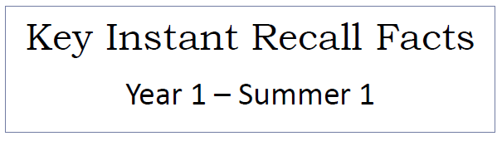


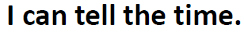

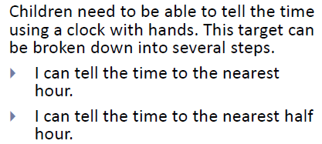
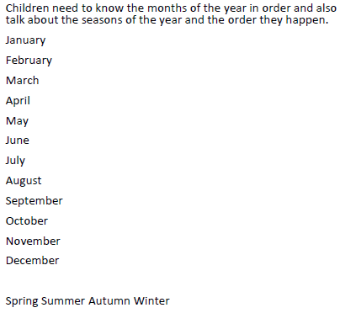Top Tips
Key Vocabulary
There are 12 months in one year
Four seasons
It is twelve o’clock
The time is half past nine
- The secret to success is practising little and often. Use time wisely. Can you practise these KIRFs whilst walking to school or during a car journey? You don’t need to practise them all at once: perhaps you could have a fact of the day.
- Talk about time – discuss what time in the year things happen. When does your child have their birthday? When is Christmas? What time do you wake up? Make sure that you have an analogue clock visible in your home or that your child wears a watch with hands.
- Read books about time - many storybooks have opportunities to talk about the seasons and predict the time of year the events take place.
- Calendars - make sure that you have a calendar to see the months pass during the year. You could also give your child some responsibility for marking off or turning over to a new month on a home calendar.


Make it real!
How many days are there in a week? 7 days in a week! Well done!

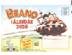
Which day comes after Wednesday?
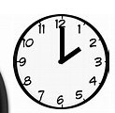
Thursday! Fantastic! Let’s look on the calendar to see what we are doing on Thursday!

What time is it?
2 o’clock! How do you know? Because the little hand is pointing at the two and the big hand is at 12. Absolutely…the small hand tells us about the hour and the big hand tells us how many minutes.
Make it fun!
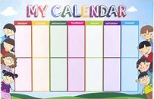 Sequencing – cut up an old calendar. Ask children to order the months and discuss the seasons as you go.
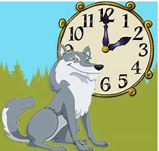
Play What time is it Mr Wolf?

Games and Apps – there are many websites and apps online with access to time telling activities.

Songs and rhymes – there are lots of CDs available with sing long options in order to help children learning to tell the time. 

