


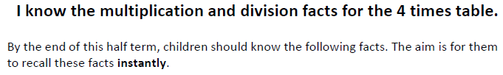

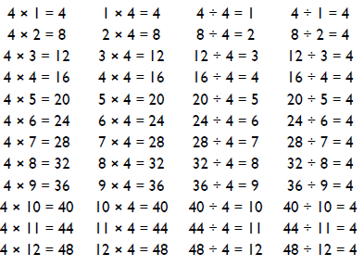
Key Vocabulary
What is 4 multiplied by 10?
What is 7 times 4?
What is the product of 8 and 4?
What is 48 divided by 12?
How many groups of 4 can you make out of 44?

Top Tips
- The secret to success is practising little and often. Use time wisely. Can you practise these KIRFs while walking to school or during a car journey? You do not need to practise them all at once: perhaps you could have a fact family of the day.
- What do you already know? Your child will already know many of these facts from the 2, 3, 5 and 20 times tables.
- Double and double again - multiplying a number by 4 is the same as doubling and doubling again. Double 6 is 12 and double 12 is 24, so 6 x 4 -= 24.
- Questions e.g. 4 x ? = 16 or ? ÷ 4 = 7
- Buy one get three free - If your child knows one fact (e.g. 4 x 12 = 48) can they tell you the other three facts in the same fact family?

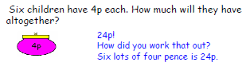
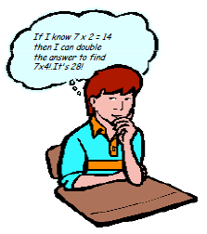
Make it Real!

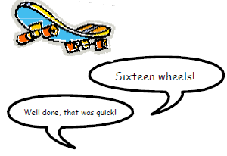

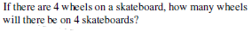




Encourage children to use doubling to work out their 4x table if they already know their 2x table. To work out 4x table facts, double and double again.

Make it fun!
Call out! Play ‘Beat the calculator’. One person works out the answer to a multiplication or division question with a calculator and the other person works it out in their head. Who is quicker?
Dice Roll a dice and generate a two-digit or three-digit number. Discuss whether the number is divisible by 4. How do you know?
Playing Cards Remove picture cards from the pack. Pick a card and state the multiplication and division fact for the four times table. E.g. pick the ‘9’ card so 9 x 4 = 36, 4 x 9 = 36, 36 ÷ 4 = 9, 36÷ 9 = 4
Dominoes To practise the 4 times table, pick a domino and add together the dots. The child multiplies the total by 4 and then give the associated division fact.
Songs and rhymes There are lots of CDs/ Apps available with musical tables. Great fun to sing along to on long car journeys!
Timed Games How well are you doing? How many questions can you answer in 2 minutes? Can you beat your own record?

