Tuesday 8th February 2022
Dividing 2-digit numbers by 1-digit numbers (with remainders)

Question 1:
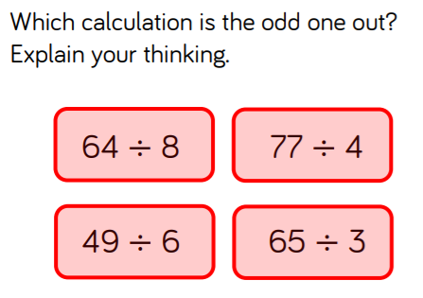
Question 2:
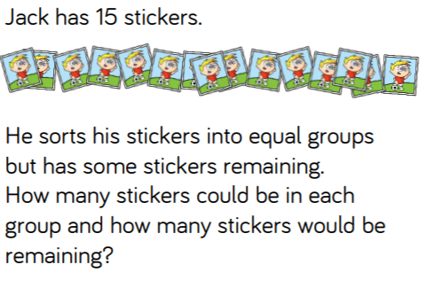

Question 3:
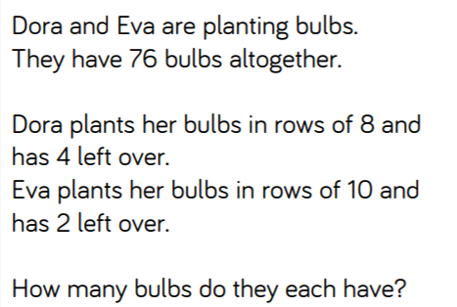

Answers on Next Page!

ANSWERS!
Question 1:
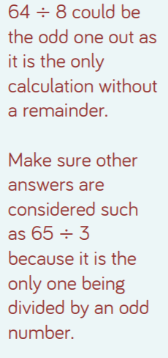

Question 2:
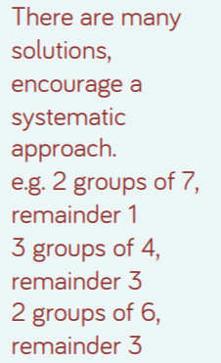

Question 3:


