‘When the Giant Stirred’ by Celia Godkin
Delving into the text!

Read the first page of the story and then answer these questions:
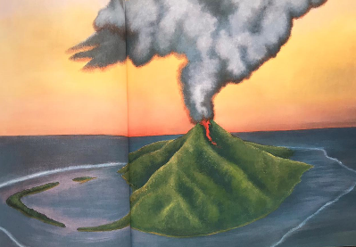
- Why do you think the author describes the island as a ‘green, green island’? Hint – what is on the island that makes it so green?
- Find and copy two words that show that the red parrots were noisy.
- Find and copy two words the author uses to describe the animals that lived in the lagoon.
- Do you think the island was a busy place? Explain why you think this. Hint – think about the words the author uses to describe the island.
- What food did the people eat on the island?
- What towered over the peaceful island?
- What simile does the author use to describe the sound the quiet mountain sometimes made?
- What did the people of the village do when the giant stirred?
- Why did they do this?
- Find and copy a word the author uses that means smell.

When a Giant stirred
Comprehension 1 - Answers
- Why do you think the author describes the island as a ‘green, green island?’ (lots of trees/forest/reference to a forest on the island)
- Find and copy two words that show the red parrots were noisy. (screech, chattered)
- Find and copy two words the author uses to describe the animals that lived in the lagoon. (strange, wondrous)
- Do you think the island was a busy place? Explain why you think this. (no, the author said it was a ‘sleepy’ island)
- What food did the people eat on the island (coconuts, fruit and fish)
- What towered over the peaceful island? (a cone-shaped mountain/a volcano)
- What simile does the author use to describe the sound the quiet mountain sometimes made? (rumbled like a giant mumbling in his sleep).
- What did the people of the village do when the giant stirred? (threw garlands of flowers into the crater)
- Why did they do this? (in the hope that the smell of the flowers would put the mountain god back to sleep)
- Find a copy a word the author uses that means smell (scent).
- Write down as many fronted adverbials as you can find in the first page of the story. (long, long ago, on the island, over all of this peaceful island, when the giant stirred, suddenly, for days after the people left – there may be more).

