‘When the Giant Stirred’ by Celia Godkin

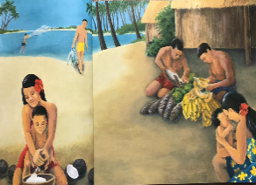
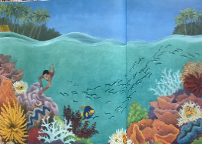
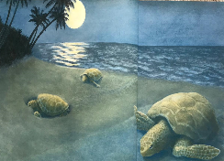
Long, long ago in a blue, blue sea lay a green, green island. On the island there were white, sandy beaches with coconut palms, where great sea turtles came by moonlight to bury their eggs in the sand. On the island, there were leafy, green forests with brightly coloured butterflies, where noisy, red parrots screeched and chattered from the treetops. On the island, there was a cool, blue lagoon, where many silvery fish swam in an underwater garden of strange and wondrous animals. On the island, there was a sleepy village of grass- thatched houses where gentle, smiling people went about their daily lives. They collected coconuts from the beaches, fruit from the forest, and fish from the lagoon.

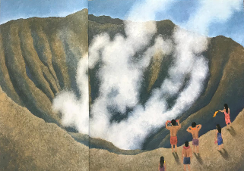
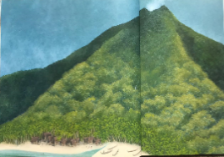
Over all of this peaceful island, towered a great, cone-shaped mountain. Most of the time it was quiet, but sometimes it let out a puff of smoke or rumbled like a giant mumbling in his sleep. When the giant stirred, the people of the village took garlands of flowers up the mountain and threw them in the crater at the top. They prayed that the sweet, heavy scent of the flowers would put their mountain god back to sleep and give him pleasant dreams.

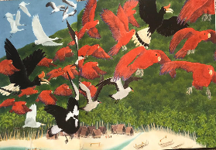
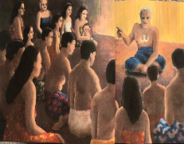
But there came a day when the mountain would not go back to sleep. It rumbled and roared. It belched out black smoke, which fell as a rain of cinders on the village. The people were afraid to go up the mountain. Instead, they huddled fearfully in their homes. Suddenly, the parrots and all the other birds flew screeching and chattering up into the sky. They made a great, colourful, noisy cloud, which flew away across the sea in search of another island on which to live. The chief of the village gathered his people around him. He told them that the birds were the messengers of the gods. He said that, when the birds left, the mountain would awake in anger, and no amount of flowers would appease their mountain god now.

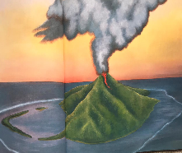
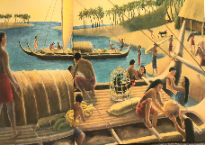
The chief told his people it was time to leave their beautiful island home. The people did as they were told, so they gathered their belongings and hurried with them to the beach. They loaded the boats and paddled away across the sea, looking for another island on which to live. For days after the people left, the mountain belched out black smoke. It rumbled and roared until the ground shook and shook and shook. Then…

