


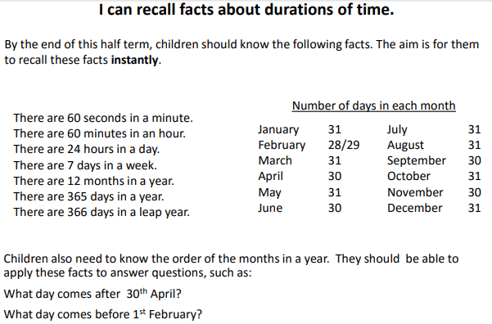
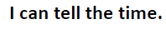

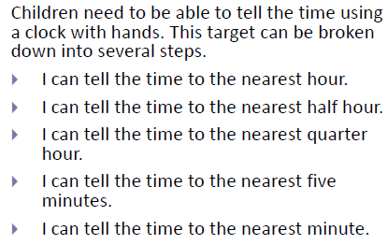

Top Tips
- The secret to success is practising little and often. Use time wisely. Can you practise these KIRFs whilst walking to school or during a car journey? You don’t need to practise them all at once: perhaps you could have a fact of the day.

- Use rhymes and memory games – the rhyme, Thirty days hath September, can help children remember which months have 30 days. There are poems describing the months of the year in order.

- Talk about time – discuss what time in the year things happen. When does your child have their birthday? When is Christmas? What time do you wake up? Make sure that you have an analogue clock visible in your home or that your child wears a watch with hands.

- Read books about time - many storybooks have opportunities to talk about the seasons and predict the time of year the events take place.

- Calendars - make sure that you have a calendar to see the months pass during the year. You could also give your child some responsibility for marking off or turning over to a new month on a home calendar. Could your child be responsible for recording the birthdays of friends and family members in it? They could even make their own calendar.

- How long is a minute –Ask your child to sit with their eyes closed for exactly one minute while you time them. Can they guess the length of a minute? Carry out different activities for one minute. How many times can they jump in sixty seconds?

