
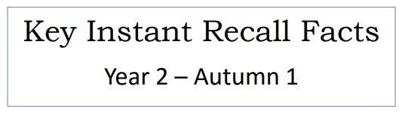
`

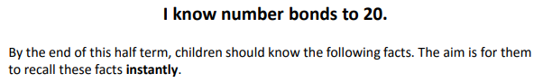

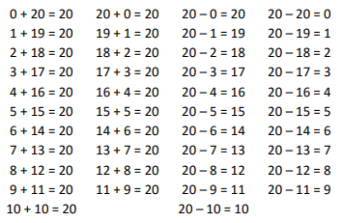

Key Vocabulary
What do I plus to 5 to make 20?
What needs to be added to 11 to make 20?
What is 20 take away 6?
What is 3 less than 20?
How many more than 16 is 20?
What is 20 subtract 13?

Top Tips
- The secret to success is practising little and often. Use time wisely. Can you practise these KIRFs whilst walking to school or during a car journey? You do not need to practise them all at once: perhaps you could have a fact of the day.
- Use what you already know- use number bonds to 10 (e.g. 7 + 3 = 10) to work out related number bonds to 20 (e.g. 17 + 3 = 20).
- Use practical resources to consider the bonds in a practical way. E.g. Make collections of 20 objects. Ask questions such as, ‘How many more conkers would I need to make 20?’
- Look at the patterns with both objects and numbers. E.g. as one number increases the other one decreases.
- Make a poster - your child could make a poster showing the different ways of making 20.
- Practise with the numbers in order and chosen randomly-remember the aim is for the child to be able to respond immediately.
- Play games- your child can play number bond pairs online at www.conkermaths.com and then see how many questions they can answer in just one minute.

Make it real!
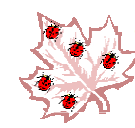
There are 20 ladybirds on the leaf. Fifteen fly away, how many are left?
5 ladybirds!
How do you know?
Well, 15 add 5 make 20.
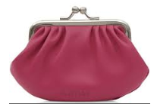
I have 4 pence in my purse. How much more do I need to make 20p?
16p! Why? Because 4 pence and 16 pence is 20 pence altogether.
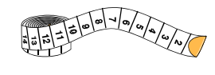

I have 20 cm of ribbon, I cut off 13 centimetres. How much ribbon is left?
7 cm! Why? Because 7 add 13 makes 20.
Make it fun!
Call out!
Play number ping-pong. Start by saying ‘ping’ and the child replies with ‘pong’.
Repeat and then convert to numbers i.e. say ‘2’ and they reply ‘18’ (number bonds to 20).

What’s hidden?
There are 20 beans on this place, I hide some under a cup- how many have I hidden?

Playing cards (take out the picture cards and use joker as zero)
- Play snap by matching the number bonds.
- Play the ‘memory game’ to find matching number bonds.
Dominoes
Connect two dominoes to make the bond.

Songs and rhymes
E.g. 20 speckled frogs, 20 green bottles, 20 in a bed

Timed games (important that if you do this, the child understands the importance of focusing on the improvement that they are making).
How many questions can you answer in 2 minutes? Can you beat your own record?

