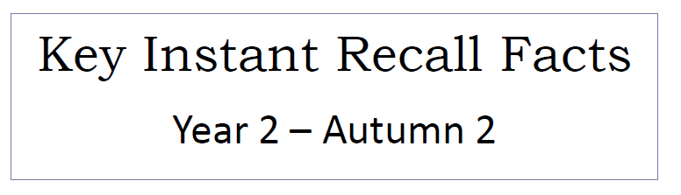


To know the multiplication and division facts for the 2 times table.
By the end of this half term, children should know the following facts. The aim is for them to recall these facts instantly.
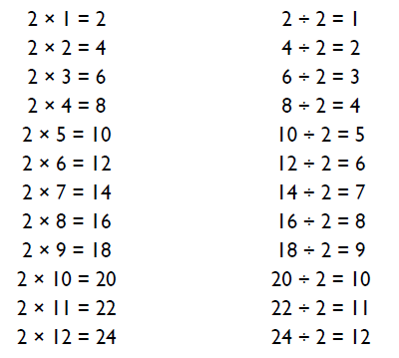
Key Vocabulary
What is 2 multiplied by 6?
What is 7 times 2?
What is the product of 3 and 2?
What is 22 divided by 2?
How many groups of 2 can you make out of 16?

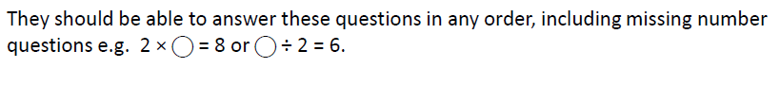
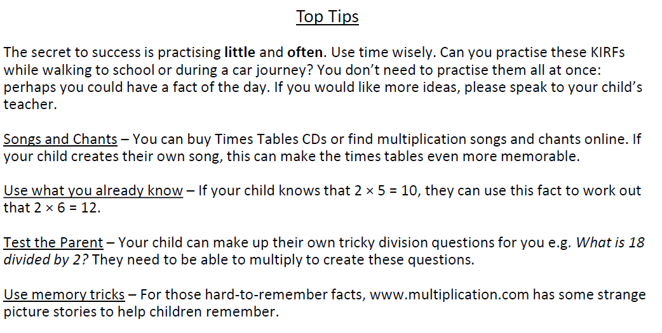

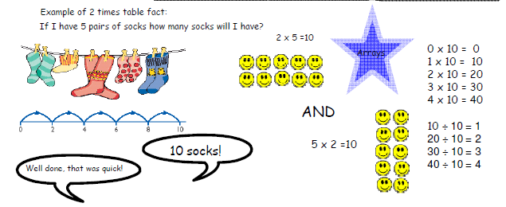

Make it Real!
There are 2 buns in one row – how many buns will be in three rows?
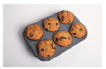
6 buns!
Great – how do you know?
Because 3 times 2 is 6.

Many other things from an array like windowpanes, milk crates, stickers and wrapping paper!

Make it Fun!
Call out!
Play Fizz Buzz. To practise the 2 and 10 time tables together, take it in turns to count in ones. If a number is in the 2x table say ‘Fizz’ instead of the number. Say Buzz if it is in the 10s.
Playing Cards
Remove picture cards from the pack. Pick a card and state the multiplication and division fact that the children are working on. E.g. pick the ‘8’ card (2 x 8 = 16 and 16 ÷ 2 = 8).
Dominoes
Pick a domino, add the number of dots together and then multiply by the table they are working on.
Timed Games
How well are you doing? How many questions can you answer in 2 minutes? Can you beat your own record?

